Internship 2022

# Progress report format for team meeting

Name: CYNTHIA KEMBOI

## Tasks completed last week

* [#83] GPS and Raspberry Pi

The raspberry pi’s OS was configured to be able to communicate with the GPS receiver. The circuit and the data collected are as shown below;

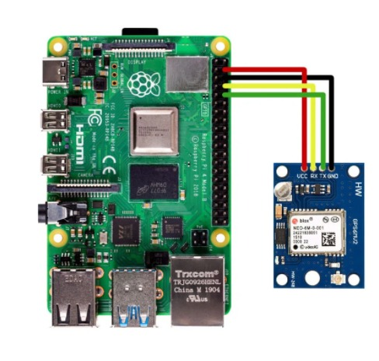

*Figure 1 raspberry pi and GPS*

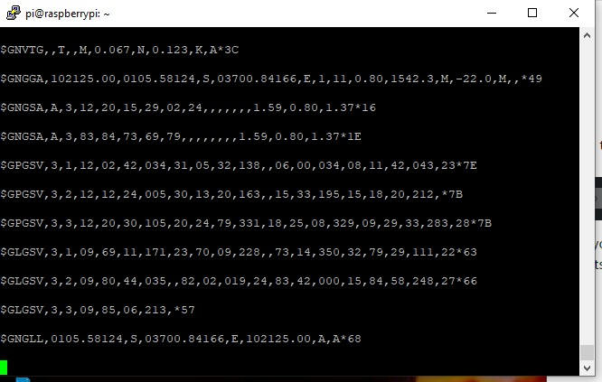

*Figure 2 data collected*

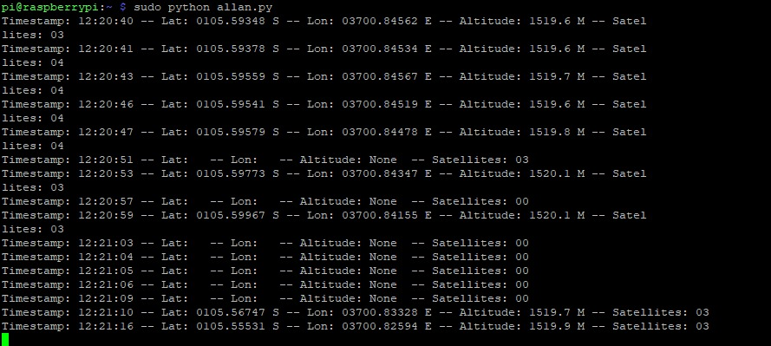

Figure 3 position of our raspberry pi

* [#87] Raspberry Pi and Compass

Magnetometer HMC5883L is used for measuring the direction and magnitude of the Earth’s magnetic field. It is used for low-cost compassing and magnetometry. It measures the Earth’s magnetic field value along the X, Y and Z axes from milli-gauss to 8 gauss. It can be used to find the direction of heading of the device. It uses I2C protocol for communication with microcontroller.

After initialization, X,Y AND Z-axis registers raw values, The head value is calculated using the following formulae:

(radian)

(Radian)

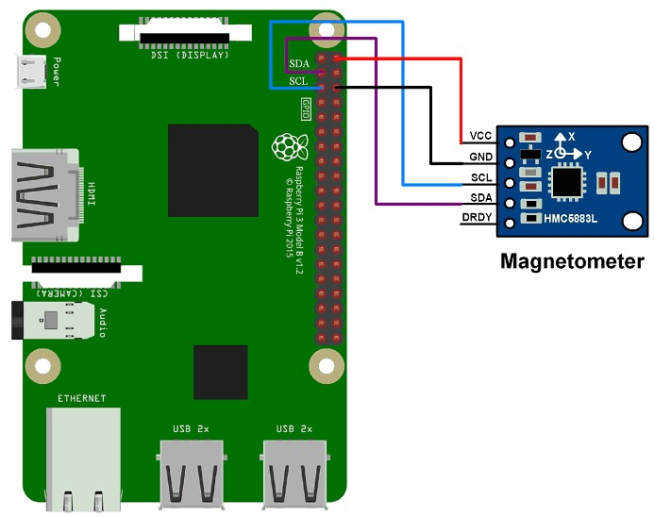

*Figure 4 raspberry pi and compass*

## 

*Figure 5 compass detected*

## **Navit**

Navit is a car navigation system with routing engine. Navit's modular design is capable of using vector maps of various formats for routing and rendering on the screen. It's even possible to use multiple maps at the same time. The GTK+ or SDL user interfaces are designed to work well with touch screen displays. Points of Interest of various formats are displayed on the map. The current vehicle position is either read from gpsd or directly from NMEA GPS sensors. The routing engine not only calculates an optimal route to your destination, but also generates directions and even speaks to you using espeak. Navit currently speaks 49 languages, can run on various platforms (Linux, Windows, Android, OpenMoko Freerunner, Wince, Nokia n800 Internet tables, iPhone, Zaurus..)

## Tasks in this week

* [#88] Raspberry Pi and Navit

# Timeline

|  |  |  |
| --- | --- | --- |
| Month | Intern week | Tasks |
| Jan |  |  |
| Week 1 | Identification of parts and drawing of the chassis diagram. |
| Week 2 | Circuit diagram and acquisition of parts. |
| Week 3 | Definition of the path to be followed by the robot car.  Laser cutting of the parts. |

|  |  |  |
| --- | --- | --- |
| Feb | Week 4 | * Assembly of the robot * Ultrasonic program implementation |
| Week 5 | * GPS and compass navigation * Path definition |
| Week 6 | Object identification using computer vision. (Raspberry pi & camera) |
| Week 7 | Transmission of live feed and data from the robot (transmitter and receiver) |
|  | Week 8 | Object dection (static and dynamic) |